Lab 09:
Objective:
- The objective of this lab is to teach students how to implement various types of inheritance (public, private, and protected) in C++.
Learning Outcome:
- After completing this lab, students will be able to identify and understand the accessibility of base class data members across different types of inheritance.
Problem Statement
Write a C++ program which should consist of following four classes.
- Base
- Derived_Private
- Derived_Protected
- Derived_Public
“Base” class should consist of following data members along with following type.
Data member | Access Specifier
secret | private
protect | protected
access | public
Further, “Base” class should contain default constructor to initialize its data members.
Other three classes should be inherited from “Base” class with respect to following type of inheritance.
Class | Inheritance type
Derived_Private | Private
Derived_Protected | Protected
Derived_Public | Public
All three derived classes should contain show() function, which should display the values of secret, protect and access data member of base class. On running this program, your compiler will generate compile time errors. Carefully observe for which type of base class data member, compiler is generating error.
Class Diagram
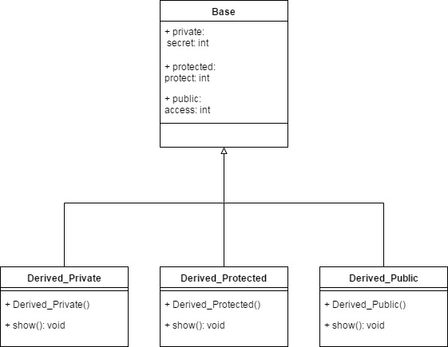
Compilation Results
